12/11/2009

|  |
| --- |
| Installation and Operation |

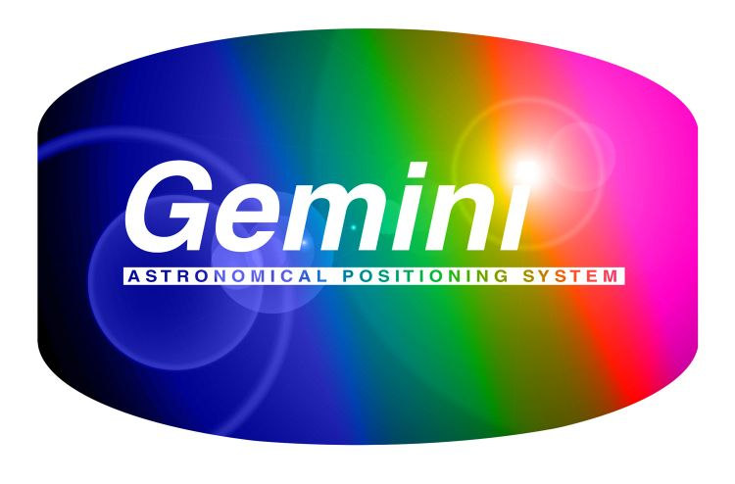

|  |  |
| --- | --- |
| ASCOM | Gemini Driver .Net |

Contents

1 Introduction 2

1.1 System Requirements 2

1.2 Installation 3

1.3 Reporting Problems with the Beta Version 4

1.4 Credits 5

2 Quick Start Guide 6

3 Basic Operation 7

3.1 Standalone Executable Mode 7

3.2 COM Server Mode 7

3.3 System Tray Icon 7

4 Driver Reference 8

4.1 System Tray 8

4.2 Virtual Hand Box 10

4.3 Gemini Telescope Setup 14

4.4 Advanced Gemini Settings 17

4.5 Joystick Configuration 25

4.6 Gemini Focuser Setup 28

4.7 Object Catalog Manager 30

4.8 Observation Log 32

4.9 Pass-Through Port Setup 33

4.9.1 Using the “Pass-Through port” with a software created virtual port. 33

4.9.2 Configuring VSPE 33

4.9.3 Using the “Pass-Through port” with a hardware serial port. 34

4.9.4 Configuring the Pass-through Port 34

# Introduction

Note: This document refers to the Beta versions of the driver, a revised version of the document will be made available for the final release of the driver.

This manual details how to use and operate the Gemini.Net ASCOM driver for the Losmandy Gemini telescope control system.

This is a totally new version of the ASCOM Gemini driver. Many new features, improvements and fixes from the old driver have been incorporated:

* Greatly improved serial port handling: the new driver should not hang up trying to find the communications port that the Gemini Controller box is installed on.
* Full control over which advanced settings are sent to your Gemini. By default the driver will not override any of your current Gemini configuration settings.
* The ability to download all your existing settings (including the PEC table) from the Gemini controller and save them file.
* A GPS interface that can be used to update the driver.
* A voice announcer, so that you can hear what is happening to your mount.
* A new pass-through port to allow non-ASCOM programs such as Gemini Control Center L4 to connect through this driver to the Gemini Control box.
* Joystick control to allow for the use of an external joystick/gamepad.
* Built-in ASCOM hub Functionality – no need to use POTH anymore[1].

Whilst the new driver completely replaces the functionality of the previous driver, they do not clash with each other. There is no need to uninstall the old driver before installing this version; both can co-exist on your computer – though of course only one can be used at any time to connect to your Gemini controller.

## System Requirements

Before you install the driver the following components must already be installed on your system:

* Latest ASCOM 5.0 Platform  
  This software can be downloaded and installed from:   
   <http://ascom-standards.org/Downloads/Index.htm>  
  The download link is on the right side of the page.
* ASCOM Platform 5.5 Updater  
  This update is in the files section of the ASCOM_Talk Yahoo! group:  
   [http://tech.groups.yahoo.com/group/ASCOM-Talk/files/Platform 5.5 Updater/](http://tech.groups.yahoo.com/group/ASCOM-Talk/files/Platform%205.5%20Updater/)  
  The file should have a name of ASCOM Platform 5.5 Updater, with a description of *Platform 5 Updater Release Candidate*. The current version as the writing of this document is:  
   ASCOM Platform 5.5 Updater RC5 (v5.5.8.14).exe
* Microsoft .Net Framework 3.5 – with Service Pack1 installed  
  This software can be downloaded from the [Microsoft Website](http://www.microsoft.com/downloads/details.aspx?familyid=AB99342F-5D1A-413D-8319-81DA479AB0D7&displaylang=en).

When installing them ensure your Windows login account has administrator privileges, and if you have User Account Control (UAC) switched on in Vista or Windows 7, right click the installer and select *Run as Administrator*.[2]

You may want to install some optional software to enable the pass-through port for non-ASCOM applications such as Gemini Control Panel.

* EterLogic Virtual Serial Port Emulator  
  This is the software used by the development team when testing the pass-through port functionality with Gemini Control Panel. At the present time this only functions on 32bit versions of Windows.  
   <http://www.eterlogic.com/Products.VSPE.html>
* com0com Null Modem Emulator  
  This implementation of virtual COM ports can be used with both 32bit and 64bit versions of Windows. Please read the ReadMe.txt for com0com for details of Windows configuration changes required to make it work correctly. Be aware that Win64 has to be run in ‘testsigning’ mode as the driver does not have a full public certificate.  
  The readme file can be found on the homepage here:  
   <http://com0com.sourceforge.net/>  
  You can download the software from here:  
   <http://sourceforge.net/projects/com0com/>

## Installation

After checking all the prerequisite software is installed download the new Gemini .Net driver from the Yahoo! Beta test group:

[http://tech.groups.yahoo.com/group/Gemini_Driver_Beta/files/Installation Files/](http://tech.groups.yahoo.com/group/Gemini_Driver_Beta/files/Installation%20Files/)

The driver installation file is located in the root folder and has a name with the format of GeminiTelescopeInstaller(1.1.x.x).exe . For example the current version as of the writing of this document is GeminiTelescopeInstaller(1.1.0.0).exe

Ensure your Windows login account has administrator privileges before you install the driver, and if you have User Account Control (UAC) switched on in Vista or Windows 7, right click the installer and select *Run as Administrator*.

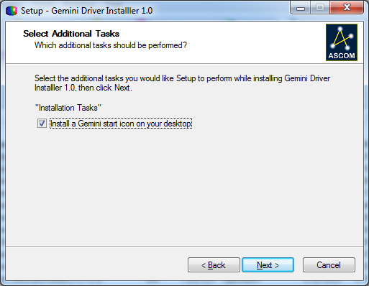When you see the below message, please DO-NOT DESELECT the “Install a Gemini Icon on your desktop” option.

If you have a previous version of the Gemini Telescope .NET driver already installed, the installer will show a message that it is removing the old driver – do not worry, the installer will leave previous your settings intact.

## Reporting Problems with the Beta Version

If you get any error messages or problems either installing or during the operation of the driver, please capture copies of any error dialogs using <Alt><PrtScn> (or the Snipping Tool in Vista and Windows 7), paste the error messages into a WordPad file and save it as a .rtf file.

Also locate any log files the driver or installers may have created in the log files folder (My Documents\ASCOM\Gemini Telescope.NET) some of these log files can be quite sizable with the amount of tracing enabled in the Beta driver. Please Zip up the logs together with any screen shot documents.

Then post a message in the user group and upload the rtf file to the Beta test Yahoo! Group. Create your own folder under the Log and Error Files folder, create the folder with your name, and then create a second subfolder under your name with the date of the error files.

If you upload more files at a later date, please create another sub-folder with that date under your name. You can see an example of this file structure below:

Log and error Files  
 ⮡ Tom Hilton (new sub-folder)  
 ⮡ 10-10-2009 (new sub-folder)  
 ⮡ Log.rtf (example of file you want to post - you may also zip them  
 if there is more than one)

## Credits

The Gemini ASCOM driver was written and developed by Paul Kanevsky, Robert Turner, and Peter Simpson. They were aided, abetted, encouraged and hindered by Tom Hilton and Mark Crossley.

A big thank you also goes out to all the Beta testers for finding those horrible little bugs!

This document was put together by Tom Hilton and Mark Crossley, with input from the developers.

# Quick Start Guide

If you just want to install the driver and use it with the minimum of fuss, then this section is for you!

1. First install (or check you already have installed) all three components of the prerequisite software listed in section  above.

* ASCOM Platform 5.0a
* ASCOM Platform 5.5 Updater
* Microsoft .Net Framework 3.5, with Service Pack 1

1. Download and install the Gemini .Net driver. Use the default settings. See section  above.
2. Connect your Gemini Controller to your computer.
3. It is recommended that the first time you run the new driver you launch it as a standalone application from the desktop shortcut. The hand box form will appear on your screen.
4. Now perform the initial driver configuration. Select Setup|Configure Telescope…
5. Set the driver to the correct COM port and serial speed, and Click [OK].
6. On the hand box, click the big [Connect] button. The Gemini should now connect to your controller.
7. This is the absolute minimum configuration needed to make the driver work. However it is advisable to download the current configuration from your Gemini and store it as the driver default advanced settings.
   1. On the handbox, select Setup|Advanced Gemini Settings… the advanced setup menu will be displayed.
   2. Click the [From Gemini] button to download all the current settings from your Gemini controller.
   3. Click the [Save] button, and use the default filename that is automatically presented.
8. You can now close the driver, select Setup|Exit.
9. You can now start your ASCOM compliant application, configure the telescope connection and select the *Gemini Telescope .NET* as the driver in the ASCOM chooser.
10. Connect your application and enjoy!

# Basic Operation

The driver can function in two modes of operation, as a standalone executable or as an ASCOM compliant COM driver. The driver will behave slightly differently depending on how it is launched.

## Standalone Executable Mode

After installing the Gemini.Net driver, you will find a shortcut on your desktop (unless you deselected this option during the installation). Launching the driver from this shortcut will start the driver in standalone executable mode.

In this mode the virtual hand box is always shown by default so that the user can interact with the driver straight away.

Even when started as a standalone executable, the driver can still be used as an ASCOM driver from your applications.

## COM Server Mode

When started as an ASCOM driver from another application (for example a planetarium or imaging program), then by default the driver will start-up in the background and the virtual hand box will not be displayed.

The driver will appear in the ASCOM chooser list as ***Gemini Telescope .NET***. As the driver can co-exist with the original Gemini driver, make sure you select the correct one.

If you wish you can change this behavior in the driver setup so that the virtual hand box is also always shown when the driver is started as an ASCOM driver.

If you wish to connect to the driver programmatically then the program IDs are as follows:

ASCOM.GeminiTelescope.Telescope

ASCOM.GeminiTelescope.Focuser

## System Tray Icon

Whichever mode the driver is invoked in it will always display an icon in the system tray area of your desktop. This icon can be used to display the virtual hand box if it is hidden, and also bring up the various setup forms available to you without having to start-up the virtual hand box.

## Help

The driver manual can be viewed at any time by pressing the [F1] key whilst in any driver dialog/form, or by using the Help!... options that appear on many menus.

***Note****: You must have a PDF reader such as Adobe Acrobat Reader, or Foxit Reader installed for this feature to work.*

# Driver Reference

## System Tray

Whilst the Gemini driver is running it will always display an icon in the Windows system tray of your desktop. Windows 7 will hide it by default, click the up arrow and select ‘Customize’ if you want it permanently visible.



When you place your cursor over this icon, a popup status panel will be displayed. This panel is shown below and provides some basic information about the Gemini system.

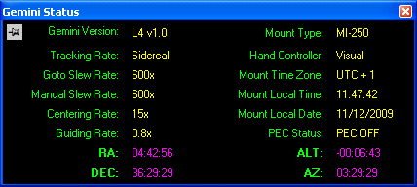

The status panel will disappear a few seconds after your cursor is removed from the Gemini driver icon. By pushing the ‘pin’ in the top left corner you can make this status panel display permanently.

By right clicking the system tray icon a menu will pop up, from which you can select the following options:

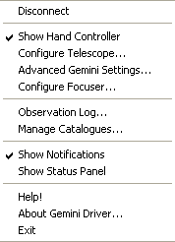

**Connect/Disconnect** – Connect or disconnect the serial connection to Gemini

**Show Hand Controller** – Shows or hides the virtual hand box form.

**Configure Telescope** – Shows the Gemini Telescope Setup form. See section .

**Advanced Gemini Settings** – Shows the Advanced Gemini Settings form. See section 4.4.

**Configure Focuser** – Shows the Gemini Focuser Setup form. See section 4.6.

**Observation Log** – Shows the Gemini Observation Log management form. See section 4.8.

**Manage Catalogues** – Shows the Gemini Catalogue management form. See section 4.7.

**Show Notifications** – Enables or disables the display of alerts and notifications from the Gemini driver system tray icon. This setting always defaults to Enabled when the driver starts.

**Show Status Panel** – Enables or disables the display of the system tray popup status panel. This setting always defaults to Enabled when the driver starts.

**Help!** – Opens the driver documentation PDF.

***Note****: You must have a PDF reader such as Adobe Acrobat Reader, or Foxit Reader installed for this feature to work.*

**About Gemini Driver** – Displays the driver credits screen.

**Exit** – Terminates the driver. If other client applications are still connected when you try to terminate the driver a warning will be displayed.

## Virtual Hand Box

The virtual hand box provides the main user interface to the driver; from here you can control the motion of the mount, and reach all the configuration menus. The Hand box can be divided up into three main areas of functionality.

|  |  |
| --- | --- |
| Untitled-3.png | Status and information display area  Motion control area  Setup and functionality |

Status and Information

The top line displays the current motion status of your mount. You will see items such as Track, Stop, Center, Slew, Park etc. displayed here.

The next three lines show the current Local Sidereal Time, Right Ascension, and Declination of the mount.

To Limit: This displays how long it will be before your mount encounters the next tracking safety limit set in Gemini. Typically you can use this to see how long it will be before you will have to perform a meridian flip when imaging.

Motion Control

The motion control area contains four large buttons that replicate the buttons on the physical Gemini handset. Pressing one of these buttons will cause the mount to move at the currently selected speed (set by the radio buttons below the large motion buttons), motion will continue until you release the button.

Like the physical Gemini hand box, you can use the checkboxes to reverse the direction of the motion buttons. This helps align the buttons with the direction the sky moves in your eyepiece or camera.

Finally in this area you can turn mount tracking on and off, and enable or disable PEC (if it has been programmed). Both these check boxes reflect the current value in Gemini, so if you switch PEC off via the physical hand box the change in status will also be reflected on the virtual hand box.

Setup and Functionality

The Connect button is pretty self explanatory.

There are three menu options available to you here:

Func Menu

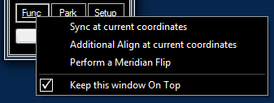

This menu provides access to the following functions:

**Sync** **at current coordinates** – Synchronize Gemini to the last target coordinates it received. If no coordinates have been sent, then an error message will be displayed.[3]

**Additional Align at Current coordinates** – Adds the last target coordinates to the current mount model. If no coordinates have been sent, then an error message will be displayed.

**Perform a Meridian Flip** – While tracking, an audible warning (a short beep about every 20 seconds) sounds some minutes before the western safety limit is reached. This gives you an opportunity to close the camera shutter or take whatever other action is necessary. If you want to continue your observation of this object, you’ll need to perform a meridian flip. This can easily be done using this button. Please note that if the mount is not where it can safely perform a Meridian Flip, it will not do so. Also while tracking an object the mount will not perform an automatic Meridian Flip.

**Keep this window On Top** – Forces the virtual hand box to always display on top of other Windows.

Park Menu

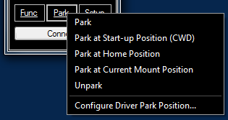

This menu provides access to the following functions:

**Park** – Parks the mount at the default park position. See the Park Behavior setting below.

**Park at Start-up Position (CWD)** – Parks the mount at the default Gemini counter weight down position.

**Park at Home** **Position** – Parks the mount at the predefined Gemini home position.

**Park at Current Mount Position** – Switches off tracking and sets the park status to true without moving the mount.

**Unpark** – Start the mount tracking at the configured rate from the current position.

**Configure Driver Park Position** – Configures the action to take when the driver receives a Park command. This default action is also the position used by the Park menu item above. Selecting this option will launch a further configuration dialog which is shown below:

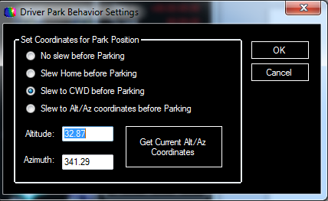

A few things to note:

* *No slew before Parking* implements a ‘Park Here’ function.
* *Slew to Alt/Az coordinates before Parking* will point the OTA in the desired direction, but if two physical positions are possible (e.g. OTA horizontal pointing North) Gemini will decide which side of the mount is appropriate.
* All park commands from this menu will display a warning message asking if you really want to perform this action. These warning messages will not be displayed if you initiate the functions using a joystick/gamepad, or from an external application, for example a planetarium or imaging program.

Setup Menu

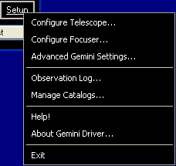

This menu provides access to the following functions:

**Configure Telescope** – The basic ASCOM type settings for communicating with the Gemini controller. See the section  *-*

**Configure Focuser** – Configure a focuser attached to Gemini. See section  *-* .

**Advanced Gemini Settings** – Configure advanced Gemini features. See section *-*

**Observation Log** – View, save and clear the Gemini Observation Log. See section  *-*

**Manage Catalogs** – Download, view, edit and upload user object catalogs to Gemini. See section  *-*

**Help!** – Opens the driver documentation PDF.

***Note****: You must have a PDF reader such as Adobe Acrobat Reader, or Foxit Reader installed for this feature to work.*

**About Gemini Driver** – Shows the driver credits screen.

**Exit** – Closes the driver, if client applications are still connected, a warning message is displayed.

## Gemini Telescope Setup

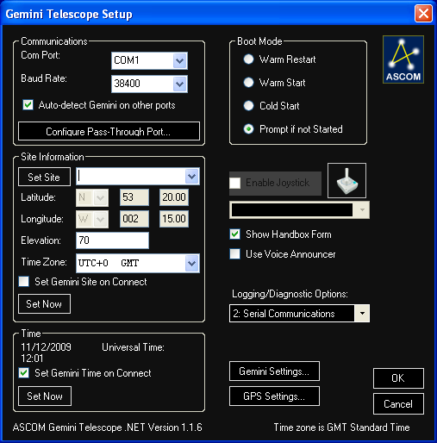

Communications

Configure the serial port and line speed to be used to connect to your Gemini controller. The speed must match the setting configured in Gemini.

**Auto-detect Gemini on other ports** – When enabled this option is enabled (the default) if the driver fails to find a Gemini controller on the configured port it will scan all the available COM ports on your system. If it finds a Gemini controller on another port it will switch to using that port. You can stop the scan process by pressing the [Stop] button on the hand controller.

If this option is disabled, then the driver will wait for 10 minutes for a response on the configured port. This should help people using wireless Bluetooth connections which can take some time to establish the connection. The timeout can be interrupted by pressing the [Stop] button on the hand controller.

Configure Pass-through Port

This button allows you to set up the driver to allow concurrent access to the Gemini controller from non-ASCOM client applications such as Gemini Control Centre. See section  *-*  for more information on this feature.

Site Information

This allows you to select from one of the four preprogrammed geographic locations in Gemini. Note that it is not possible to configure the preprogrammed sites via the driver; this must be done via the physical Gemini hand box.

The elevation information has to be populated manually in the driver (though it will attempt to pick up this information from a GPS if one is attached). The elevation is not used by Gemini but may be required by other ASCOM applications.

***Note****: Once you have selected a site by name – the name entry will not be displayed on subsequent invocations, though the latitude and longitude will be.*

Time

Displays to current UT of your computer, the check box instructs the driver to send the PC to your Gemini controller every time it connects.

Boot Mode

Instructs the driver on the action to take if it finds the Gemini controller is waiting at the boot menu when it connects. The default action is to prompt the user for the action to take.

Enable Joystick

Enables the use of a joystick to control your Gemini. Refer to section  *-*  for more information on this feature.

Show Hand Box Form

When checked the driver hand box will always be displayed when the driver is started by a client application. When the driver is started as a standalone application the hand box is always displayed.

Use Voice Announcer

The driver can make use of the PCs text to speech engine. When checked the pop-up form below will be displayed. If any voices are installed on your PC they will be listed in the drop down selection, you can select which types of messages are announced using the checkboxes.

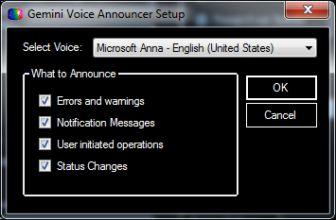

Logging/Diagnostic Options

This controls the detail of information that is recorded in the driver log files. The log files are located in My Documents\ASCOM\Logs yy-mm-dd\ with a filename like GeminiDriver.Nethhmmss.txt. When functioning normally, it is suggested you leave this logging level set to None, for troubleshooting purposes set to full logging.

Gemini Settings

This button provides access to the Gemini Advanced Configuration form. Refer to section  *-*  for more details.

GPS Settings

This button provides access to the GPS configuration form. You configure the port number and speed of the serial port on your PC to which the GPS is connected. There are options for automatically updating the PC clock from the GPS, and manually performing a query.

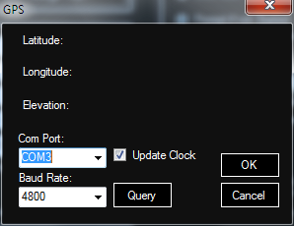

Ensure that your GPS is set to output NMEA data at the same serial speed, and is not set to SiRF or some other proprietary protocol. This form only updates from the GPS when you press the [Query] button whilst it is updating, the Query button will change to [Stop]. Pressing either the [Stop], [Cancel], or [OK] button will halt the GPS update. Pressing either the [OK] or [Cancel] button will close the form.

## Advanced Gemini Settings

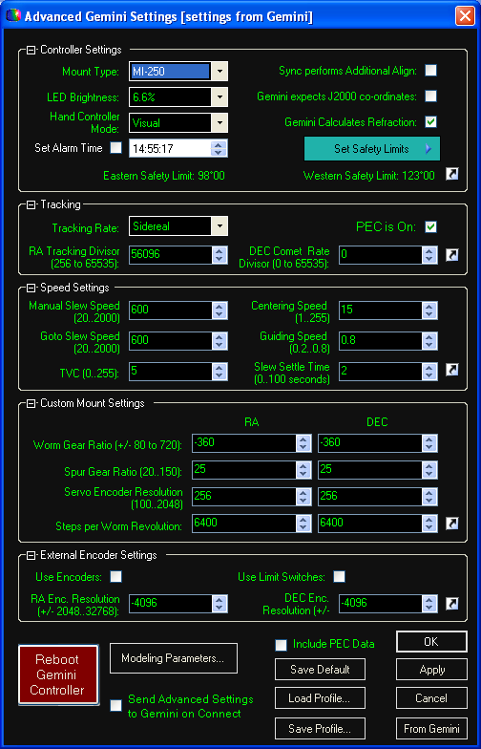

General Description

This form is where most of the Gemini specific configuration is carried out. As a result it is the most complex form in the driver. This form now opens with the custom mount setting minimized as default. Each of the sections can be collapsed or expanded by clicking on the small button to the left of the section name. This is useful for reducing the complexity of the display if for instance the Custom Mount Settings or Speed Settings are not something you need to change.

All the settings here are collected together into a ‘profile’, a profile can be saved to and load from a file on your computer. The driver creates a default profile file called GeminiDefaultProfile.gp, and will load this every time the driver starts. You can save and load profiles using any filename you like.

Once the form has loaded a profile, all the settings from this profile can be sent to Gemini by clicking on the [Apply] button, or by clicking [OK]. If the Gemini system is disconnected then pressing either the [Apply] or [OK} buttons will save the changes the Default Profile, this is the equivalent of pressing the [Save Default] button.

Here's a list of everything that is saved as part of the profile:

* All settings under Controller Settings, including safety limits
* All settings under Tracking
* All settings under Speed Settings
* Custom mount settings are used only if Mount Type is set to Custom
* All External Encoder settings
* All modeling parameters
* All of PEC programming (if "Include PEC Data" is checked)

Once you load a profile from file, the title of the Advanced Settings window will indicate the name of this profile (Profile092009-withPEC.gp) for example.

When the profile has been loaded, you can make changes to it, for example, selecting a different hand-controller mode, or different slewing speed. Once you make any desired changes, you can save the profile to a file using the [Save...] button, or send it to Gemini using the [Apply] button.

You can load, modify, and save back to a file any of the saved profiles even while Gemini is disconnected.

The idea of a Gemini profile is to store the complete state of the Gemini controller in a file that can be restored and modified later.

For example, if you save a profile, then remove the 3V CMOS backup battery causing a complete reset, and then load the saved profile and apply it to Gemini, your Gemini will be restored back to almost the state it was in before the reset.

***Note:*** *Due to limitations of the Gemini Firmware, if you remove the battery and then restore a profile, you will not be able to add to the modeling parameters using additional align. Gemini only allows you to backup and restore the major terms; the complete model which includes all the alignment points used to create the model is not available for download.*

Each of the sections can be collapsed or expanded by clicking on the small button to the left of the section name. This is useful for reducing the complexity of the display if for instance the Custom Mount Settings or Speed Settings are not something you need to change.

***Note:*** *The Custom section will be collapsed by default unless you select Custom as the mount type in the Controller Settings section.*

The data in each section can be either updated with the values currently stored in Gemini, or the form values sent to Gemini by clicking on the small curly arrow in the bottom right of each section. This pops up a mini-menu allowing one of these two operations to be selected.

***Note:*** *Setting some parameters after the Gemini system has booted will require a restart of Gemini to implement the changes:*

* *Mount Type*
* *Change of Hemisphere*

***Note:*** *If restoring the mount type results in a change in the mount type (say from the default Titan50) then you must ‘Synchronize’ Gemini in order to restore the alignment of the model to the sky.*

Controller Settings

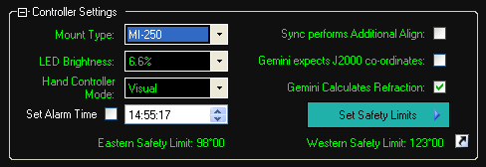

This section set some basic properties of the Gemini controller. Most important is the mount type, selecting the correct type here will set a number of other fields on the form to relevant defaults.

**Hand box settings** – You can also set the physical hand box display brightness, and mode (visual, photo, all speeds) to be set on connection.

**Synch Performs Additional Align** – Controls the effect of a synchronize command received from a client program. ASCOM only implements a single synchronize command, it has no concept of synchronizing to add to a model, setting this parameter allows you to build a Gemini pointing model by using a ‘Goto’, ‘center’ (in eyepiece or camera), and ‘synchronize’ sequence in your favorite planetarium program.

**Gemini Expects J2000 Coordinates** – By default Gemini expects epoch of the day (so called JNow) coordinates to be provided as a goto destination. Most planetarium software does send JNow coordinates, but if yours can only send J2000 then you need to set this parameter. This setting only affects coordinates sent to Gemini, all coordinates sent out of Gemini are JNow.

***Note****: This is a global setting, if you send goto commands from multiple programs they should all use the same coordinate epoch – Jnow or J2000.*

**Gemini Calculates Refraction** – By default Gemini will allow for the effects of refraction when pointing at an object, use this setting to switch off this behavior.

**Set Alarm Time** – Enables the setting of a beeper alarm on the Gemini system. This can be useful for reminding you of upcoming astronomical events or TV programs. Note that a ‘feature’ of the Gemini system means the time field may be reset whilst you are entering the time if serial communications are taking place.

Set Safety Limits – This button gives you access to two features: setting the safety limit to the current mount position, or predefining the safety limits in degrees from the counter weight down position. This latter function pops up a new configuration dialog.

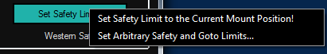

**Set RA Safety Limits** – This form allows you to set explicit safety limits for your mount. If you do not understand how safety limits work it is recommended that you use the defaults for now and read the Gemini manual before proceeding.

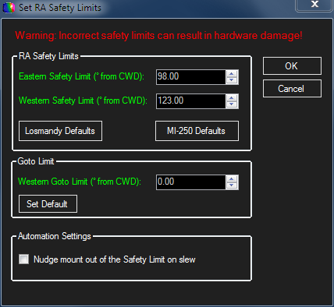

The Eastern and Western limits can be set manually, or the [Losmandy Defaults] and [MI-250 Defaults] buttons can be used to populate the limit fields to factory default values for these makes of mount. Many people have found that the Losmandy default Eastern limit is too aggressive and can cause mount collisions, so the driver will warn you of this and give the option of setting a safer more conservative setting.

**Goto Limit** – The Goto Limit is used by Gemini to determine if a meridian flip is required for a Goto command. The default value of zero means that Gemini will set the Goto limit 2.5 degrees before the relevant safety limit.

**Automation Settings** – Lastly the Automation Settings is a brand new feature of this driver. Normally if Gemini tracks into a safety limit the mount stops and has to be manually backed away from the limit before you can Goto your next target. Whilst this is a minor inconvenience for someone local to the mount, it is a major problem for automated operations.

If this parameter set it invokes a one second slew, at the currently configured slew rate, away from the safety limit. This feature is used by all ASCOM slew commands, including Alt/Az slews and equatorial slews. It is also used when a park command is issued that requires the mount to move from the current position. The driver waits for the one second slew to complete, and then issues the desired slew/park command, as usual.

Tracking

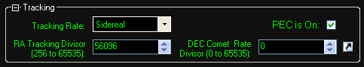

Use this section to set the tracking speed, you can select from the standard Gemini tracking speeds, or set your own by altering the RA tracking rate divisor. Please refer to the Gemini manual for an explanation of how to determine the divisors. The declination divisor is used when setting a custom rate to track an object such as a comet or asteroid that moves in both RA and declination – again the Gemini manual has an explanation of the ‘Comet’ rate.

This section also controls whether periodic error correction (PEC) is enabled or not when the driver connects. PEC is only available after either ‘training’ the mount or uploading a PEC table to Gemini from the driver or another program such as PEMPro. PEC can be toggled off/on via a button on the hand box after the driver is connected to your Gemini controller.

Speed Settings

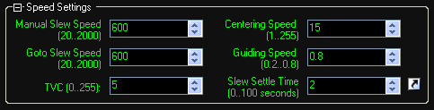

Used to set the various normal slew and guiding speeds. TVC helps compensate for the response delay caused by gear backlash when changing direction in Dec.

Slew Settle Time is a delay added by the driver to slew commands. Once Gemini reports that the slew has completed, the driver will wait the specified time before reporting back to the client application that the slew is complete. This allows the mount to ‘settle’ and gear backlash to be taken up before the client starts taking an image exposure for example.

Custom Mount Settings

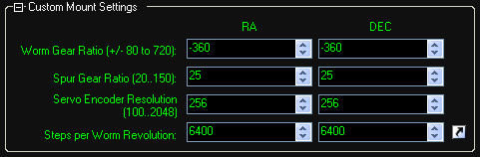

This section will normally be collapsed unless you select Custom as the mount type in the Controller Settings section. You can use this section to setup your Gemini controller for a non-Losmandy mount, or if you change to non-standard gearboxes etc. Please refer to the Gemini manual for details on setting up custom mounts.

External Encoder Settings

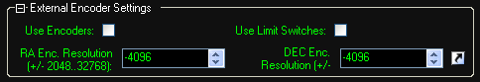

Losmandy mounts can be used with external shaft encoders which are used to track the mounts position if the clutches slip. Use this section to enable and configure your encoder settings.

**Use Limit Switches** – Enabling this allows Gemini to respond to external physical movement limit switches. These are typically used to prevent mount collisions with piers, domes etc. Please refer to the Gemini manual for details of how to wire up limit switches to Gemini.

Modeling Parameters

This button pops up another form where you can see (or alter – caution!) the current Gemini mount modeling parameters.

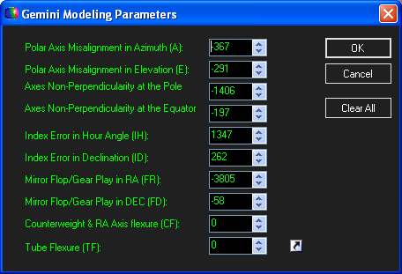

These parameters are saved along with rest of the mount configuration by default. Use the curly arrow to download the latest values from your Gemini controller.

All the parameter values are displayed in arc seconds; please refer to the Gemini manual for an explanation of all the values.

Load/Save/Send Options

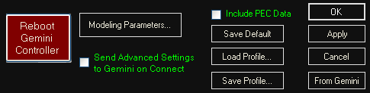

**Include PEC Data** – Enabling this option means the driver will download and upload the PEC data to your Gemini controller whenever you click [From Gemini] or [Apply]. Note that the PEC table can be quite large and may add some time to length of these operations.

**Save Default** – Used to save the current Gemini settings displayed on the form to the default profile file – *GeminiDefaultProfile.gp*

**Load Profile** – Loads a previously saved Gemini settings profile file into the driver. You can save multiple files to allow for different mount configurations, geographic locations etc.

**Save Profile** – Saves the current Gemini settings displayed on the form to a user named profile file. All profile files must have a .gp file extension.

**Apply** – Sends all the currently configured driver settings to your Gemini controller. Note that you can send each section individually by clicking on the small curly arrow in that section.

**From Gemini** – Downloads a complete set of settings from your Gemini controller, overwriting the current values in the forms. Note that you can download each section individually by clicking on the small curly arrow in that section.

**Send Advanced Settings to Gemini on Connect** – Instructions the driver to always send all the advanced configuration settings to your Gemini controller each time the driver is connected. Useful if you want to always set your configuration back to a known state at the beginning of each observing session.

**Reboot Gemini Controller** – Forces the Gemini controller to reboot. The driver will then take action configured in the Telescope Setup form (section above) when Gemini reaches the Boot menu option.

## Joystick Configuration

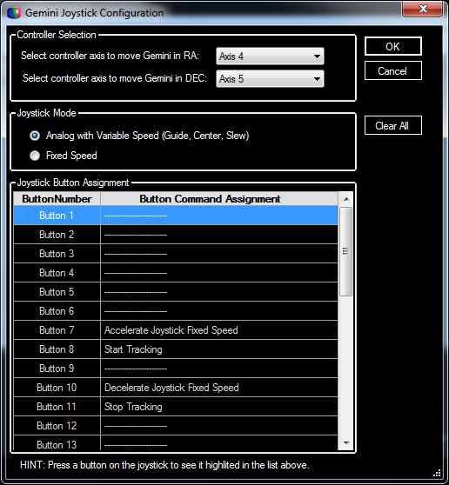

The Joystick Configuration form allows you to configure how the different controls and buttons on your gamepad/joystick will map to functions in the Gemini Driver. The settings shown above are for a Wingman Wireless Rumble pad controller.

Controller Selection

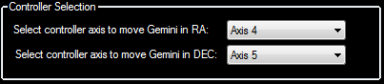

The Axis selection for both RA and Declination let you assign movement in these axes to one of the analog controls of the gamepad. In the case above, Axis 4 and 5 were for the right stick.

Joystick Mode

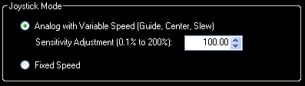

This section allows you to select either *Analog with Variable Speed*, or *Fixed Speed*.

Analog with Variable Speed enables the ability to control the speed of the Gemini movements via the size of deflection applied to the stick. A small movement of the joystick starts to move at Guide speed, further movement of the stick in the same direction will switch to Center Speed, with still further movement accelerating to Slew Speed.

Use the sensitivity adjustment to fine tune the response of your joystick; settings less than 100 reduce the sensitivity, settings greater than 100 increase the sensitivity.

In Fixed Speed mode means the joysticks will always move the mount at the speed you have selected on the Gemini Control menu. It is possible to change this speed setting by assigning one of the buttons on the gamepad to perform this function – see the next section.

Joystick Button Assignment

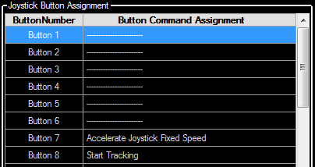

This is where you can assign driver functions to joystick buttons.

The screen shot above shows that Button 7 has been assigned to accelerate the Joystick speed, and button 10 to decelerate the joystick speed.

Pressing a button on the joystick controller will highlight its position under Button Number. Pointing your mouse at this highlighted position will present a selection menu where you can assign a task to that button. The dropdown menu presented is show below:

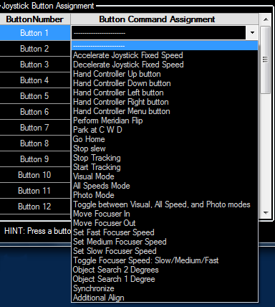

## Gemini Focuser Setup

The Gemini controller can be interfaced to an external focuser control unit such as the James Lacey Stepper Interface. The Gemini .NET driver allows you to control this focuser via the hand box or joystick and it also provides an ASCOM interface to allow other ASCOM clients to control the focuser.

The Gemini Focuser .NET presents an Absolute focuser to the ASCOM interface.

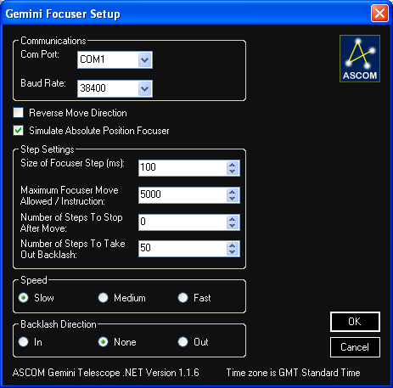

Communications

Set the Com port and serial line speed to communicate with the Gemini controller. Please refer to the focuser interface manual on how to interface the Gemini controller to a focuser unit.

**Reverse Move Direction** – swaps the in and directions of your focuser around. Useful if the focuser moves in the opposite direction to what you expected.

**Simulate Absolute Position Focuser** – toggles how the Gemini Focuser appears to other ASCOM programs. When this option is ticked the driver will report itself as an Absolute focuser, when cleared as a relative focuser. The Gemini Focuser uses a stepper motor, but is strictly neither and absolute nor a relative device but a hybrid. Select the option that best suits your purposes, absolute is the default value.

Step Settings

This section defines how the Gemini focus control appears to other ASCOM programs that may want to control it.

**Size of focuser step (ms)** – Corresponds to the ASCOM Focuser.StepSize Property. The ASCOM property defines the step size in microns; this value defines the minimum movement a focuser can make. As the Gemini focuser control interface does not provide control over the focuser steps the best we can do is specify the minimum movement time.

**Maximum focuser move** **allowed / instruction** – Corresponds to the ASCOM Focuser.MaxIncrement Property. Defines the maximum number of steps the focuser is allowed to move by a single Focuser.Move command.

**Number of steps to stop after move** – Implements a braking feature, after you stop the focuser movement, it backs up this number of steps to allow for overshoots in the system.

**Number of steps to take out backlash** – defines how far the focuser will move past the required focus position and then reverse to take system backlash.

Speed

Select the movement speed for your focuser. The actual values for the slow, medium, fast movement speeds are set within the external focuser interface.

Backlash Direction

Select the direction (if any) from which you always wish to approach the desired focus point to remove backlash from the system. Useful if the focusing system has any mechanical slop.

## Object Catalog Manager

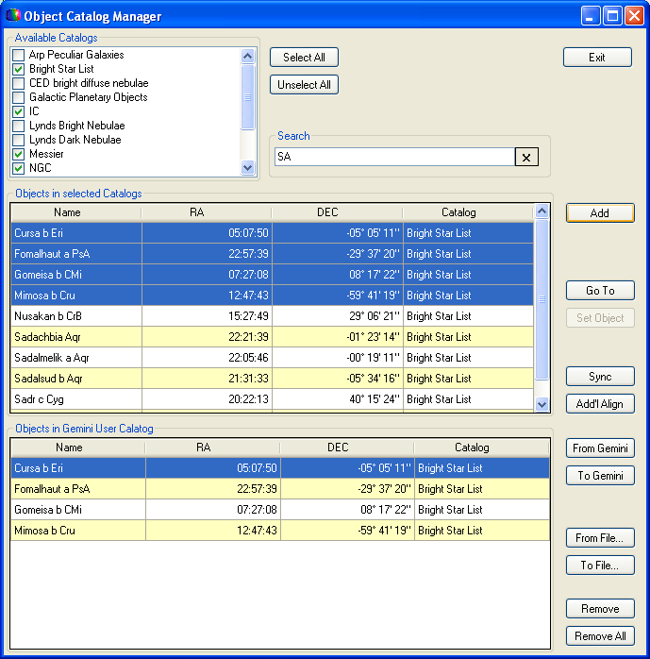

This form allows you to create, save, and load custom created catalogs for use with Gemini. The form gives you access to all the built-in Gemini catalogs, as well as a number of other predefined catalogs that you may find useful (13 in total). You can build a custom catalog directly from the driver, picking only the objects you want from any or all of the available catalogs.

Once you have built a custom catalog, you can upload it to your Gemini, or save it to a file.

You can also use any of the catalogs directly from the driver, just highlight the required catalog entry and press the [Go To] button, or you perform a [Sync] or an additional align [Add’l Align] using that object.

The following catalogs are provided within the driver:

* Arp Peculiar Galaxies
* Gemini Bright Star List
* CED bright diffuse nebulae
* Galactic Planetary Objects
* IC Catalog
* Lynds Bright Nebulae
* Lynds Dark Nebulae
* Messier Objects
* NGC Catalog
* SAO Catalog
* Sharpless HII Regions
* VDB reflection nebulae
* Washington Double Star Catalog

If the provided catalogs do not contain the objects you are interested in, you can also create your own new reference catalogs. A catalog file is a plain text file, with the following format:

object_name1,RA_coord1,DEC_coord1#  
object_name2,RA_coord2,DEC_coord2#  
...

***Note:*** *The RA and DEC coordinates are J2000, and the object name is limited to 10 Characters.*

Here is an example:

Alnitak Ori,05:40:45,-01:56:34#  
IC433, 5:40:31,-11:39:57#  
VDB142,21:36:41,57:30:08#

Save the new catalog into the same folder as the other driver catalogs and you will be able to search it and use it just like all of the other catalogs in the driver catalog manager. Note that the file name must end with an extension of .guc

The catalogs are saved in Windows XP in:

C:\Documents and Settings\All Users\Application Data\ASCOM\Gemini Telescope.NET\Catalogs

and for Vista and Windows 7 in:

C:\Program Data\ASCOM\Gemini Telescope.NET\Catalogs.

## Observation Log

Gemini keeps an internal log of all the objects to which you have command it to slew. This form allows you to manage that log.

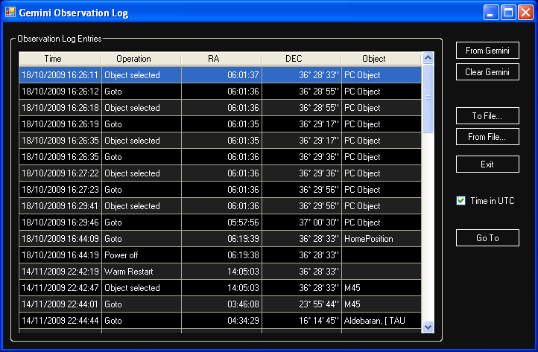

**From Gemini** – Downloads the observation log from the Gemini controller into the driver. The log in the Gemini controller is not altered. Gemini can hold about 900 entries in the log, once it is full it stops adding any further entries.

**Clear Gemini** – Clears both the form and the observation log in your Gemini controller – if it is connected. So beware; if you want to preserve the entries save them to a file before pressing this button.

**To File…** – Saves the current observation log displayed in the form to a file. The file format is in plain text so you can import it into any tool you wish.

**From File…** - Loads a previously saved observation log from a text file. This may be useful if you wish to see the dates/times in your local time zone – see below…

**Time in UTC** – Controls the display format of the observation log date and time. By default Gemini uses UTC for observation log entries, clearing this setting will convert them to your local time zone.

**Go To** – Highlight an entry in the log and press this button and if your Gemini is connected to will attempt to slew to the object.

## Pass-Through Port Setup

The pass-through port is designed to allow non-ASCOM applications to share the serial connection with the ASCOM Gemini .NET driver. It achieves this by linking to a second serial port which can be either a physical hardware serial port or virtual serial port created with software. The non-ASCOM application links to this second serial port and any data sent by the non-ASCOM application is picked up by the Gemini driver, and forwarded over its serial connection. The Gemini driver keeps track of what data has been sent by the non-ASCOM application and collects any responses from the Gemini controller and sends them back out of the pass-through port to the non-ASCOM software.

### Using the “Pass-Through port” with a software created virtual port.

In order to perform this feat you will have to install some third party software to create the virtual serial port. The diagram below is the configuration you would have if using GCC with the virtual serial port.

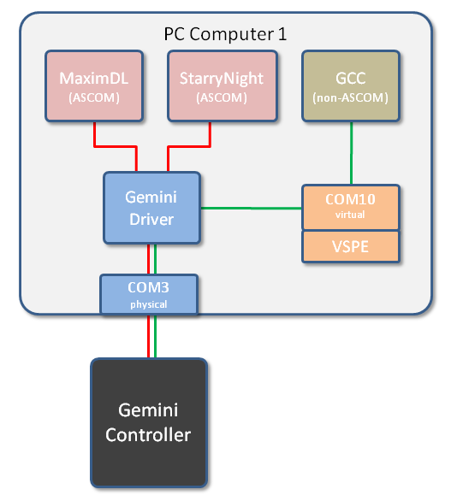

*Pass-through configured to use a virtual COM port*

The Gemini driver pass-through port was developed and tested using a package called VSPE (virtual serial port emulator). This can be found at <http://www.eterlogic.com/Products.VSPE.html>. There are other virtual serial port packages available, both free and pay ware.

### Configuring VSPE

Download the VSPE package from the link way down at the bottom of the page link above (last download button).

When the software has been installed, run it, and create a new serial connection port. It must have a different COM number than any of the existing COM ports, and especially than the one you use for connecting Gemini. For instance if Gemini is connected to COM4, and create COM10 as the serial virtual port.

To create the new connection port:

* Click on the [Create new Device] button
* Select Device Type as "Connector", click [Next]
* Select Virtual Serial Port (COM10), click [Finish]

You now have a new serial port, COM10 that can be used by GCC (or other non-ASCOM software) and the Gemini driver to talk to each other.

### Using the “Pass-Through port” with a hardware serial port.

The diagram below is one way to use the “Pass-Through port” with a hardware serial port.

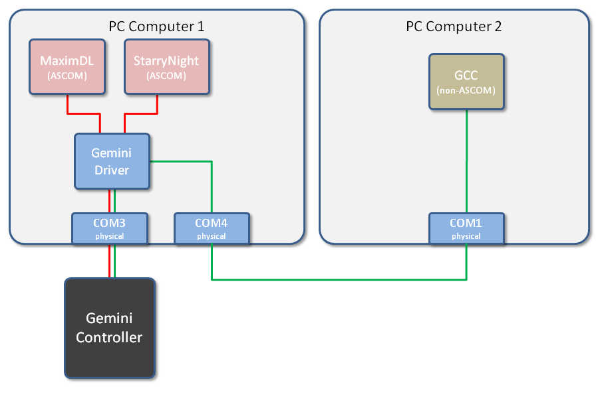

*Pass-through configured to use physical ports on two computers*

This diagram shows using two computers. One running the Gemini Driver and ASCOM based programs, and the second computer running a non-ASCOM program such as GCC.

### Configuring the Pass-through Port

To configure the Pass-Through port, start the Gemini driver. From the setup button, select the Advanced menu. Below the serial port setup for the Gemini is a small box that says “Configure the Pass-through port.” Click anywhere in this box to get the below menu. Set the Com Port to your desired setting. Make sure not to select the same port as the Gemini Driver to Gemini port, or the port number being used for the GPS. A suggested port number is COM10, and 9600 baud. Make sure that "Enable Pass-through Port" is checked (port 10, 9600 baud is just a suggestion).

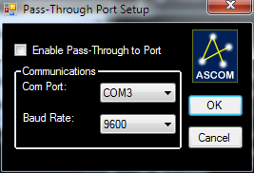

Connect the Gemini driver to Gemini. Then, start GCC (or other non-ASCOM software) and select COM10 as the port to use to connect to Gemini. Then, connect GCC to the telescope.

You should now have both, GCC and Gemini driver connected to Gemini controller. You can start PemPro, TheSky, and any other software you like that uses the ASCOM driver, and they will all continue to work while GCC is still connected and controlling Gemini.

***Note:*** *When using GCC with Gemini Telescope .Net and the virtual pass-through port, GCC will only scan ports COM1 through COM12 to find your Gemini. So if you are planning on using GCC ensure that you limit your virtual port to the range COM1 through COM12.*

1. Unless you need to slave Dome control in which case you will still need to use POTH.
2. Strictly this is not required even if UAC is enabled as installers should automatically be elevated, but some people have reported problems with installs without this additional step.
3. This command is not affected by the checkbox on the Advance Setting menu, “Sync performs Additional align.”